Darker the Night
A Novel
By Lisa London
Media Kit
- Sell Sheet
- Media Release
- Author Biography
- Praise for Darker the Night
- Ten Things You Might Not Know About Germany and WWII
- Sample Interview with the Author

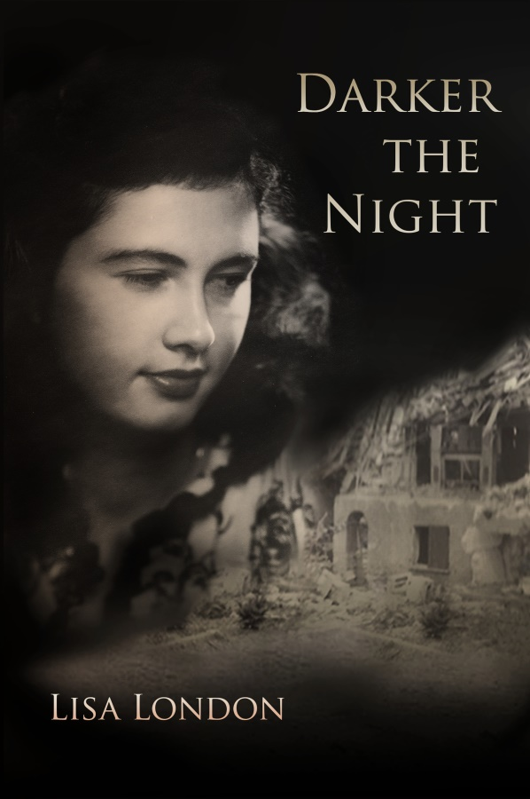
Darker the Night
Inspired by a true story, this fascinating tale tracks an extraordinary young woman as she perseveres through the challenges of Hitler’s Germany.
“…a stunningly realistic, absorbing quality that will make it a powerful juxtaposition to Diary of Anne Frank, recounting the youth experience from quite a different vantage point and making it a special recommendation…”
Midwest Book Review-D. Donovan, Senior Reviewer
Hedy spends her childhood playing with her Hitler Youth group in the hills of Western Germany. When the Führer’s troops march across Europe, Hedy is determined to help the soldiers by becoming a physical therapist. The Nazis, however, have other plans. Suddenly she finds herself assembling airplanes, dodging bombs, battling hunger, and standing up to the invading tanks.
As the pride in her country is shattered with the news of the Nazi atrocities, her father reminds her, “The darker the night, the brighter the stars.” Is her star the charming American Counter-Intelligence Agent who keeps appearing in unusual places?
HISTORICAL FICTION
ISBN: 9780991163557 Trade Paper
286 pages, US $18.95
ISBN: 9780991163564 Large Print
502 pages, US $24.95
ISBN: 9780991163571 E-Book
US $ 9.95
Publication Date: February 8, 2016
Distributor: Publisher, Amazon, Smashwords & Ingram
Contact: Susan Sipal, publicity@deepriverpressinc.com

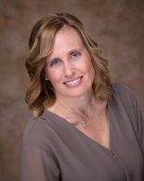
ABOUT THE AUTHOR: Lisa London is the author of the top-selling Accountant Beside You series of books for nonprofit organizations. Her friend Hilde Sensale’s stories of growing up in Germany during World War II inspired her to write Darker the Night. Lisa now hopes that people’s eyes no longer glaze over when they ask what she is writing. www.DarkerTheNight.com

MEDIA RELEASE
CONTACT: Susan Sipal, 919-444-9395
Email: publicity@deepriverpressinc.com

MY NEIGHBOR WAS A HITLER YOUTH
www.DarkerTheNight.com
MOREHEAD CITY, NC— Author Lisa London will debut her historical novel, Darker the Night, on February 8 in honor of local German war bride, Hilde Sensale’s, 90th birthday at the Leon Mann Jr. Enrichment Center in Morehead City at 11:00 am.
London, author of the top-selling Accountant Beside You series of books for nonprofits and churches, was inspired to write Darker the Night after her friend, Mrs. Sensale, spoke of enjoying the outings of her Hitler Youth group. “It was fun. As young girls, we were allowed to go play in the mountains and do things proper young women weren’t supposed to do.”
After encouraging her friend to share more experiences, London realized the intrigue of a novel from the perspective of a German civilian. Darker the Night follows Hedy’s desire to become a physical therapist to assist the soldiers as she is thwarted time and time again by the Nazis. Instead she must assemble airplanes, dodge bombs, battle hunger, and stand up to invading tanks.
As the pride in her country is shattered with the news of Nazi atrocities, Hedy’s father reminds her, “The darker the night, the brighter the stars.” Is her star the charming American Counter-Intelligence Agent who keeps appearing in the oddest places?
D. Dovovan, Senior Reviewer for The Midwest Book Review made the story a special recommendation. “…a stunningly realistic, absorbing quality that will make it a powerful juxtaposition to Diary of Anne Frank, recounting the youth experience from quite a different vantage…”
Each chapter begins with a historical quote or piece of WWII propaganda. “I want the reader to get a feel for what was influencing the average German citizen at the time,” said London. Video interviews with the woman who inspired the story are available at www.DarkerTheNight.com and Youtube.com.

Media kit and photos are available at www.DarkerTheNight.com. London may be contacted for interviews and appearances. For booking presentations, media appearances, interviews, and/or book signings, contact publicity@deepriverpressinc.com or the author directly at 919-770-3746.

Author Biography

Lisa London
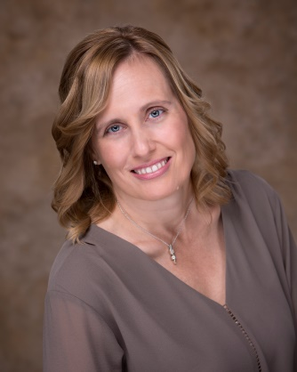
Lisa London began writing books as The Accountant Beside You when she realized nonprofit and religious organizations often had non-accountants doing the bookkeeping, but had few resources on how to do it. She knew it would take rather creative writing to make people want to read a book on accounting, but she was up to the challenge. The books in her Accountant Beside You series are being used by thousands of organizations across the world. Lisa is looking for a nonprofit in Antarctica, just so she can claim it has been read on every continent.
Having been bit by the writing bug, she began to see stories all around her. When her neighbor Hilde mentioned how much she had enjoyed her Hitler Youth group, Lisa was intrigued. Not long after that, Lisa was helping her 100 year-old Granny pack up things and found a beautiful embroidered tablecloth that looked almost new.
“Granny, I’ve never seen you use this. Why not?”
Sadness engulfed her grandmother’s face. “My brother, Bud, told me he got it off a German family when he was in the war. Every time I used it, I pictured that poor German family with a bare table.”
Needless to say, it broke Lisa’s heart to see her grandmother so sad. When she mentioned it to her German neighbor, Hilde stopped her.
“Tell your grandmother her brother helped a German family. We were starving after the war. So people would trade their table linens for food. If the American soldiers had not ignored the non-fraternization rules, many of us would have starved.”
Not only did this make her grandmother feel much better, at that point, Lisa knew she had a novel that had to be written–a World War II novel written from the German civilian perspective.
Lisa’s husband Skip and their four children think she has completely forgotten how to cook or to help on their small farm in North Carolina. When not writing, Lisa enjoys spending time on the coast, paddle boarding, kayaking, and boating with the family.
Connect with Lisa on Facebook at https://www.facebook.com/darkerthenight/. She is available to contact for interviews at 919-770-3746 or email publicity@deepriverpressinc.om.

Advance Praise for Darker the Night
Midwest Book Review—D. Donovan, Senior Reviewer
Enter the story in 1944 (World War II), where the blast of an air raid siren sends two girls tumbling from their beds and into a basement shelter; then go back in time to 1937, where Hedy is a winner in a competition certain to make the Fürher proud of his young warriors. This win will earn her a position in his Youth Gathering in Cologne, a high honor, indeed, for one not yet fourteen.
Hedy's classmates are in the SS and in special corps serving the Fürher, and their lives take on new meaning in an adult world where they are usually directed instead of respected.
More so than most similar books about Hitler's youth movement, Darker the Night chooses a powerful character (Hedy) to portray how youth were affected by his ideals and encouraged to participate in increasingly dark events. It's often about seeking and gaining approval from peers and adults alike: and just as frequently, events pose a strange juxtaposition between adult training and concerns and a child's eye view of the world just beginning to change as they teeter on the cusp of adulthood: "Grinning, Hedy picked it up and swung back. Frieda seized a pillow and returned fire. Soon all of the girls were throwing pillows and shrieking. Laughter, squeals, and feathers filled the room as they fell on top of one another."
By interspersing these moments of a child's life and innocence with the insidious unwinding of events to come, London's survey succeeds, more so than most young adult reads, in capturing the flavors of both the times and the sentiments of young people determined to fit in and establish a position for themselves in life.
As Hedy continues to mature and comes to make some difficult decisions about friends, enemies, and her future, she finds herself constantly walking a thin line between survival and ethics, making decisions that often tend to thwart the effects of starvation and challenges to life itself: "Dammit, Hedy, every time I visit you, I ask, ‘What do you and your family need?’” He stopped and drew a deep ragged breath. “You lied to me. You insisted you did not need a thing. Your family is starving and you won’t tell me? What kind of relationship is this?” Squirming, Hedy explained …"I didn’t want you to think I was dating you to get food.” Hedy fought back the tears swelling in her eyes. “I never wanted you to question my motives.”
And as she interacts with Americans and Germans alike, she savors the good things that evolve in her world (for, yes, there is good - it's not all darkness) and battles against those which would drag down her and her family.
Each chapter opens with a quote from a speech or piece of propaganda to give a flavor of the times and its influences, and each section offers new opportunities for reflection and understanding; because just as events in Germany weren't singular, so Hedy is a complex character whose perceptions aren't based on political correctness today, but on the experiences of a young German citizen confused about her country's direction and its real actions.
Against this backdrop, Hedy's coming of age isn't just political: it's a personal saga, throughout. This approach gives the book a stunningly realistic, absorbing quality that will make it a powerful juxtaposition to Diary of Anne Frank, recounting the youth experience from quite a different vantage point and making it a special recommendation for a companion read and contrast to Anne Frank's more famous Diary's perspective.

From Donovan’s Bookshelf http://donovansliteraryservices.com/reviews.html
The Pick of the Month-January 2016
What psychological and political forces lead to a young person's recruitment in an ethically questionable, ultimately horrifying series of events? Events surrounding the development of Hitler's Youth Corps are strikingly portrayed in Darker the Night, a vivid story of young Hedy, a winner in a competition certain to make the Fürher proud of his young warriors. This win will earn her a position in his Youth Gathering in Cologne, a high honor, indeed, for one not yet fourteen.
Young adults receive a thought-provoking and powerful story of how youth were affected by his ideals and encouraged to participate in increasingly dark events in a vivid read especially recommended as a companion view of the other side when pursuing the Diary of Anne Frank.

Darker the Night
A Novel by Lisa London
Ten Things You Might Not Know
About Germany and WWII

- When Hitler invaded Russia, he confiscated the German civilians’ snow skis for the military to use.
- The Nazi party would schedule large parades on the Catholic Church’s feast days and require its members to attend to discourage church attendance.
- Approximately 8 million people were in the Nazi Party at its peak. This was only 10% of the population, and many were members only because their jobs required it.
- Young men and women were required to do a six-month work service called Arbeitsdienst even before the war. Once the war was in full swing, an additional war duty called Kriegsdienst was added. The men were drafted into the military, and the women were sent to factories or other areas of need.
- German civilians were only allowed to listen to specific radio stations. Nazi party officials required a large orange tag hung on the knob to remind them which stations they could listen to.
- After the invasion, American soldiers were forbidden to speak with the German population
- The rule was relaxed after a few months to allow the soldiers to speak to children. This directive was widely ignored, and in July 1945, General Eisenhower lifted the restriction, but still discouraged fraternization.
- After the war, the Allies issued occupation currency, called Alliierte Miltarbehorde, which was printed in the US and the Soviet Union. However, a barter economy known as cigarette currency was more commonly used (which also made fraternization more likely).
- Once Germany surrendered, the Allies would not allow food relief from the International Red Cross or other organizations into the country. Between labor shortages in the fields, lack of fertilizer (had been used in the bombs), and bad weather, the farmers could not produce nearly enough food to feed the population. The Germans were starving.
- The U.S. first lady, Mrs. Roosevelt, was against allowing servicemen to marry German women unless the man first came home and “had sufficient time to be quite sure that his love was not born of loneliness and propinquity in a strange country.”

Darker the Night
A Novel by Lisa London
Sample Interview with Lisa London
(919) 770-3746
Why did you choose to write a book about World War II?
My very lovely neighbor, Hilde Sensale, mentioned being in the Hitler Youth. I was shocked. I always had pictured the Hitler Youth as young men in uniforms with one arm sticking out. I began quizzing her about life in Germany before, during and immediately after the war. I hadn’t fully realized how much the civilian population was controlled by the Nazi party.
What did your neighbor say about being in the Hitler Youth that surprised you so?
She said it was fun. As a young girl, she was allowed to go hike in the mountains, run, do gymnastics; all the things proper young women weren’t supposed to do. As a young girl, she didn’t understand the politics.
Is this book Hilde’s biography?
No, I wanted to take some of her stories and play with them.
So which part of the book actually happened?
The reader should assume that anytime Hedy does something courageous, intelligent, or entertaining, it was something the real Hilde had done. If it was foolish, ridiculous, or puts her in a bad light, blame me.
Go to www.DarkerTheNight.com to see some of my interviews with Hilde. You can get the stories in her own words.
What was the most challenging part of writing the book?
The research. I was asking Hilde to remember things from over seventy years ago, so I double checked every event as much as possible. By the way, her memory is phenomenal. Also, I wanted the reader to get a feel for what the German civilians were hearing, so I added quotes from historical figures or propaganda pieces to each chapter. This took almost as long as writing the book, as I wanted them to tie both to the time and the subject of the chapter.
Did you learn anything that Hilde didn’t already know?
Actually, I did, which made my day, by the way. When the American soldiers arrived in their tanks into Noviand, she told me they were celebrating in the back yard. (Unfortunately, they found the community wine cellar and were using chickens as target practice.)
Noviand is a very small town, so I couldn’t understand why the soldiers would be celebrating. But while researching the American tank movements, I found a diary post of a soldier who had been in Noviand. He stated that once they arrived there, they were notified they would receive the Combat Infantry Badge, which meant extra pay. It was fun to get to explain to Hilde, seventy years later, why the soldiers were celebrating so.
How does Hilde feel about the book?
She is pretty excited. I scheduled the publication date for February to coincide with her 90th birthday. What a great way to celebrate.
When and where can we buy the book?
Darker the Night will be published February 8, 2016 and is available in bookstores, Amazon.com, and DarkerTheNight.com.

